TRAFFIC CONTROL STRATEGIES REPORT
Document Title: Traffic Control Strategies Report
Project: Cluster 6 – Darvycom Australia
Unit: ICTTEN615 – Manage Network Traffic
Prepared by: Leonardo Matias Ciarcia
Date: 03/02/2026
Version: 1.0

1. Purpose
The purpose of this report is to identify traffic control strategies that can be applied to the Darvycom Australia network to prevent congestion, protect critical network services and maintain acceptable network performance.
The strategies are based on the traffic analysis performed using PRTG Network Monitor and other network troubleshooting methods.

2. Traffic control objectives
The main objectives are to:
- Reduce the risk of congestion
- Protect critical services
- Maintain acceptable latency and packet loss
- Prevent network device overload
- Control unnecessary traffic
- Improve network availability
- Provide sufficient bandwidth for important applications

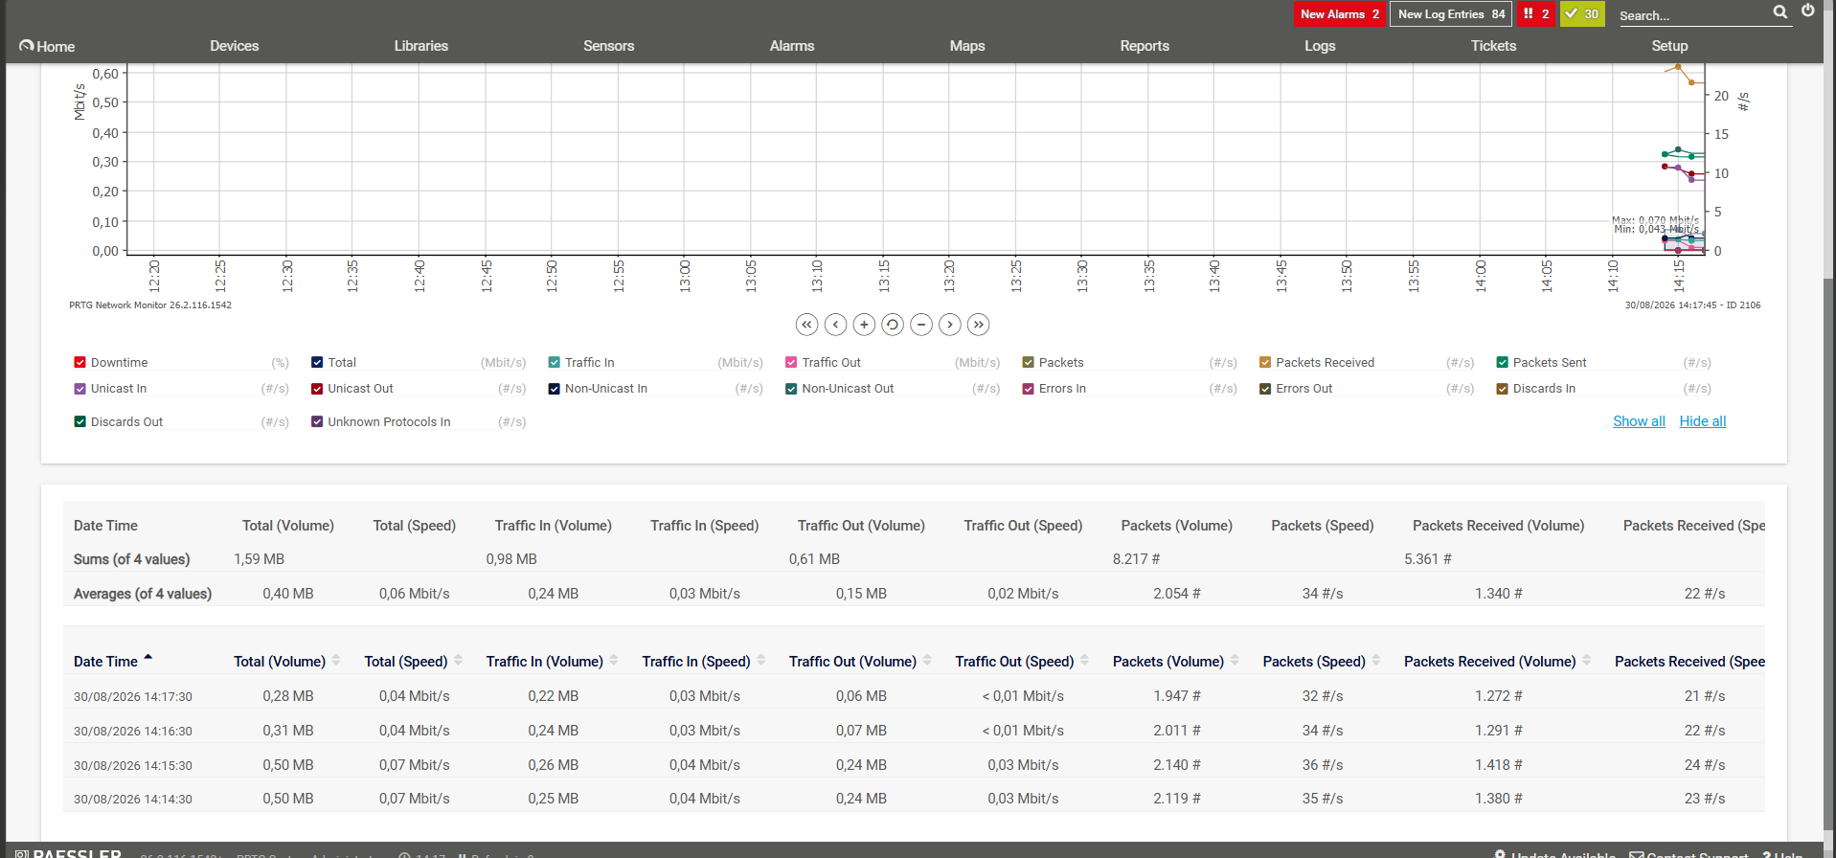Bandwidth utilisation

3. Recommended traffic control strategies

3.1 Network monitoring
PRTG should continuously monitor important devices, interfaces and services.
Monitoring allows the technical team to identify:
- Increasing bandwidth utilisation
- Packet loss
- High latency
- Device failure
- High CPU utilisation
- Interface errors
- Abnormal traffic patterns
Warning and critical thresholds can be configured so corrective action can be taken before users are significantly affected.

3.2 Quality of Service
QoS should be used to prioritise critical applications.
Higher priority should be given to services such as:
- VoIP
- Video conferencing
- Critical business applications
- Network management services
Lower-priority traffic should receive reduced priority when congestion occurs.

3.3 Traffic shaping
Traffic shaping can control the rate at which selected applications or users consume bandwidth.
This can help prevent large downloads or background applications from using excessive network resources.

3.4 Rate limiting
Rate limiting can restrict the maximum bandwidth available to selected services, users or network segments.
This prevents a single application or device from consuming excessive capacity.

3.5 Blocking unnecessary traffic
Firewall rules, ACLs and acceptable-use policies can restrict traffic that is not required for Darvycom business activities.
Examples include:
- Unnecessary streaming
- Peer-to-peer traffic
- Unauthorised applications
- Excessive personal downloads

3.6 Scheduling high-volume activities
Network-intensive activities should be scheduled outside peak operating periods.
Examples include:
- Server backups
- Software deployment
- Operating system updates
- Cloud synchronisation
- Large file transfers

3.7 Load balancing
Where multiple network resources are available, traffic can be distributed between them to prevent a single device or service becoming overloaded.

3.8 Capacity improvement
Where monitoring demonstrates that the existing network cannot support traffic requirements, additional bandwidth or higher-capacity networking equipment may be required.

4. Traffic control strategy table
Traffic-control strategy | Preventive action | Trigger or condition | Responsible person | Expected result
PRTG threshold monitoring | Continuously monitor Traffic In, Traffic Out, Traffic Total, latency, packet loss, CPU and availability | Simulation warning at 154 Mbit/s and error at 187 Mbit/s; production thresholds recalibrated using onsite measurements | Network administrator | Early identification of congestion before services fail
QoS prioritisation | Prioritise VoIP, video conferencing and business-critical applications over downloads and general web traffic | Applied whenever delay-sensitive traffic shares a congested interface | Network engineer | Reduced voice delay, jitter and packet loss
Voice bandwidth reservation | Reserve sufficient bandwidth for twenty simultaneous G.711 calls | Approximately 2.18 Mbit/s including the 25% allowance | Network engineer | Maintains acceptable IP-telephone performance
Bulk-traffic control | Rate-limit, pause or reschedule software downloads, backups and large file transfers | Activated when utilisation approaches the warning threshold | Network administrator | Releases capacity for operational services
Off-peak scheduling | Schedule backups, system updates and large transfers outside business peak periods | Repeated high utilisation during normal operating hours | Systems administrator | Reduces competition between business and background traffic
VLAN segmentation | Separate data, voice, wireless, server and management traffic into dedicated VLANs | Applied throughout the final Network 3 design | Network engineer | Limits broadcasts and improves traffic control and security
Route and link management | Monitor both network routes and use the available alternative route when a primary path becomes unavailable or congested | Ping sensor Down, packet loss, excessive latency or route failure | Network administrator | Maintains availability and reduces dependence on one route
Alert and escalation procedure | Generate a PRTG notification or ticket when a threshold remains exceeded | Traffic above warning level for 30 seconds or sensor changes to Warning/Down | Network administrator/project manager | Ensures the problem is investigated promptly
Capacity review | Review PRTG historical data and forecast future demand | Planned Darvycom load is 66.18 Mbit/s on the 100 Mbit/s capacity model; review when sustained use exceeds 70% | Project manager and network planner | Allows upgrades before the network reaches critical utilisation
Upgrade constrained links | Replace remaining 100 Mbit/s bottlenecks with Gigabit Ethernet and review WAN capacity | Sustained utilisation above 85% or forecast demand exceeding available capacity | Project sponsor and network engineer | Provides sufficient capacity for future users and services
Configuration and rollback control | Back up configurations and document changes before applying QoS, routing or bandwidth policies | Before every planned network change | Network administrator | Allows unsuccessful changes to be reversed safely
Periodic strategy review | Compare alarms, complaints, traffic graphs and capacity forecasts | Monthly or after a major incident/network change | Technical specialist | Keeps traffic-control strategies aligned with actual demand

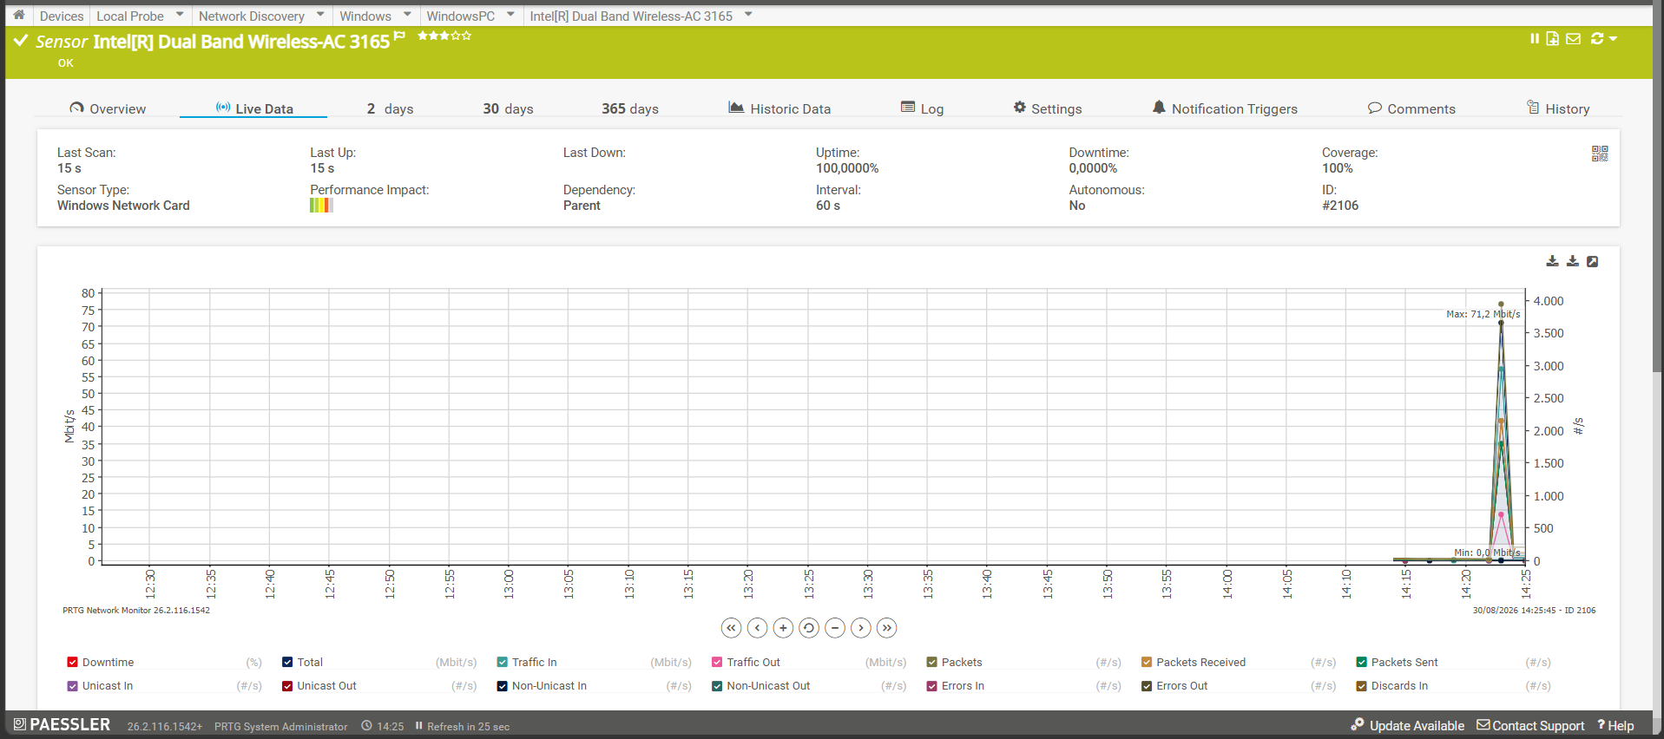

“The increase in bandwidth utilisation demonstrates how additional network demand can create higher loading on a network link. If sustained, this type of traffic growth could contribute to congestion.”

5. Monitoring effectiveness
PRTG should be used before and after traffic controls are implemented.
Measurements should include:
- Bandwidth before the change
- Bandwidth after the change
- Packet loss
- Latency
- Throughput
- CPU utilisation
- Availability
The results should confirm whether the selected traffic control strategy improved network performance.

“Controlled PRTG threshold test demonstrating an alert when the monitored value exceeded the configured limit.”

6. Recommendations
Darvycom Australia should use a combination of monitoring, QoS, traffic shaping, filtering and capacity management.
PRTG historical information should be reviewed regularly to determine whether temporary controls remain effective or whether permanent network upgrades are required.

7. Conclusion
Traffic control strategies help Darvycom Australia maintain stable network performance and reduce the risk of congestion.
Using PRTG together with appropriate network controls provides a proactive approach to managing traffic and protecting critical services.

